WINDOW LOG INVESTIGATION
41. Event logs open karo
Run
Eventvwr
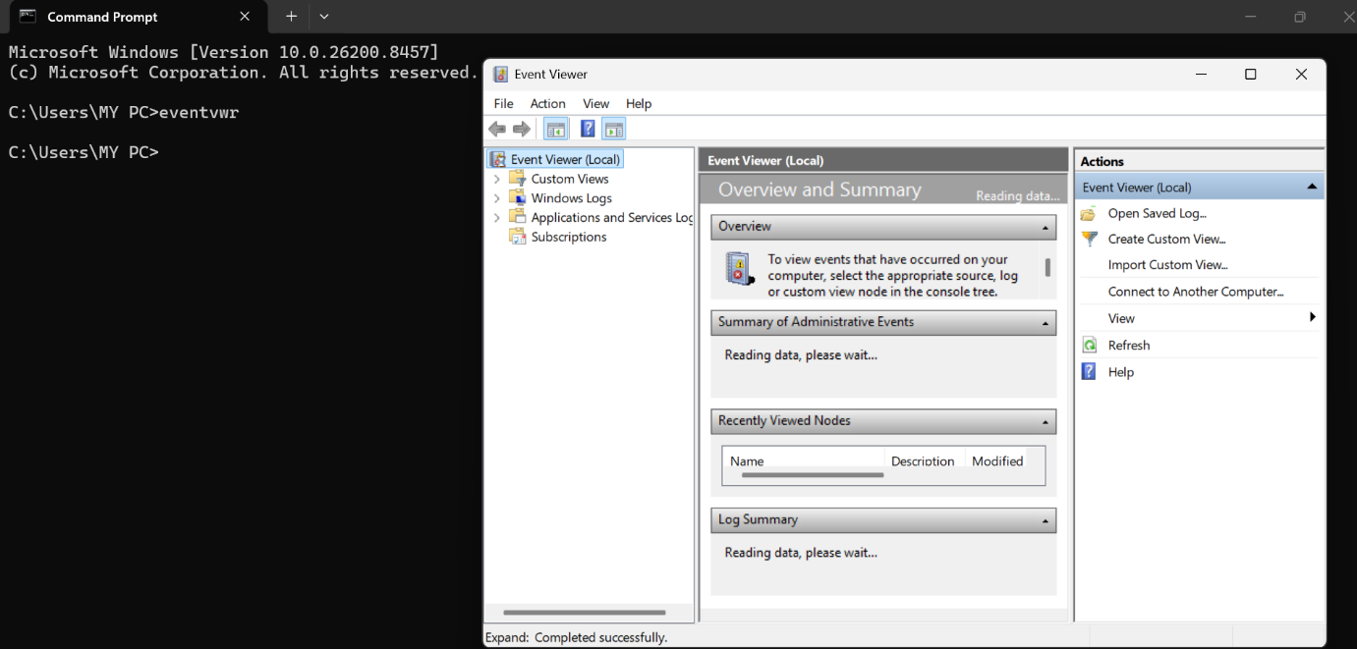
SOC POV
Security events analysis.

42. Failed login events search karo
Event ID
4625
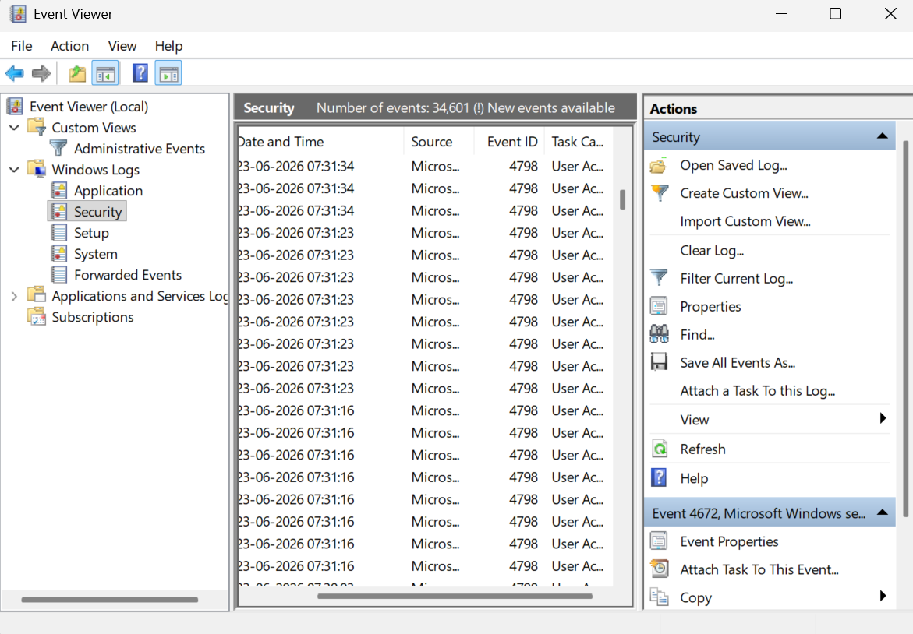
SOC POV
Brute force detection.
Event viewer – window logs – security logs then check for id 4625

43. Successful login
Event ID
4624
SOC POV
Unauthorized access.
Idhar 4624 dekhna hai

44. New user creation
Event ID
4720
SOC POV
Attacker account creation.

45. Process creation logs
Event ID
4688
SOC POV
Malware execution.

46. Service installation
Event ID
7045
SOC POV
Persistence technique.

47. Account lockout
Event ID
4740
SOC POV
Brute force attempts.

48. System shutdown logs
Event ID
1074
SOC POV
Attack cleanup attempts.

49. Audit policy change
Event ID
4719
SOC POV
Security tampering.

50. Log clearing event
Event ID
1102
SOC POV
Attacker covering tracks.

